FRIPP ISLAND FRIENDS OF MUSIC MEMBERSHIP 2023-2024

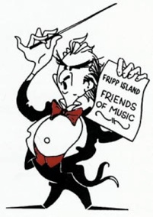
Membership to the FOM is a great value! You get admission to all five concerts and are invited to a complimentary “Meet the Artist” catered reception after the concert. Our goal is to build a steady membership base to fund the artists, assist young musicians and promote our Arts-in-the-Schools program. A Basic Membership saves you $50 per person over the cost of buying individual $30 tickets for each concert!

We have three membership levels above the Basic. These are for the concert goers who want to have an even greater impact on the future of music in the schools in the Low Country. Your additional contribution is added to the Peg Gorham Memorial Fund and is tax-deductible! See the back of this page for more information about how the Friends of Music impacts music in the schools, via the Peg Gorham Memorial Fund as well as the Hildy Aldrich Memorial Fund.

Questions about membership? Call or text Membership Chair, Vanessa Peñaherrera, at (704) 807-0255, or email vandy116@gmail.com When you arrive at the concert, please check in at the membership table.

NAME(S)_______________________________________________________________

ADDRESS_____________________________________________________________

CITY___________________________ STATE ___________ ZIP CODE ___________

EMAIL _____________________________________________________________

MEMBERSHIP TYPE (circle one) *contributions above the Basic level are tax-deductible

INDIVIDUAL COUPLE
Basic $100 $200
Patron $150 $300
Benefactor $250 $500
Maestro $500 $1000

“HILDY ALDRICH FUND” CONTRIBUTION $____________ (see reverse side)

TOTAL AMOUNT ENCLOSED $____________

Please make checks payable to Fripp Island Friends of Music and mail to (or drop off to our cocktail box slot at our mailbox next to the Community Center):

Fripp Island Friends of Music
Attn: Membership
217 Tarpon Blvd.
Fripp Island SC 29920

FOM can also help you promote your business. We accept business-card size through full page advertising in our printed concert program. Our loyal concertgoers patronize our advertisers! A half page or larger ad includes membership for two. Call Advertising Chair Cindy Wray for details. (740) 821-2292

The FOM also meets the criteria for matching corporate funds and IRA distributions (our Charitable Tax ID: 570756201). If you work (or worked) for a company that matches contributions to non-profit organizations, please consider asking for a matching grant to your contribution to the FOM. Contact Laura Furgeson at laurajfurgeson@gmail.com for more information.

Find us on the web at www.frippfriendsofmusic.com Like us on Facebook!

FRIENDS OF MUSIC IMPACT ON THE SCHOOLS

Peg Gorham Memorial Fund.

Fripp Island Friends of Music arranges for our performers to visit a Beaufort County school on the morning after each Fripp concert. With performances tailored for the younger ages, these talented musicians captivate their student audiences, exposing them to a world beyond the Sea Islands. In addition to our school visits, Fripp Island Friends of Music supports local young musicians with scholarships and financial contributions, particularly to the Beaufort Youth Symphony Orchestra. See more at https://www.frippfriendsofmusic.com/music-in-the-schools.html. All this is thanks to the Peg Gorham Memorial Fund. https://www.frippfriendsofmusic.com/peg-gorham-memorial-fund.html

Surplus Operating funds (from memberships, advertising, and other sources) may be transferred to the Peg Gorham account to increase our contribution to the Music-In-The-Schools activities.

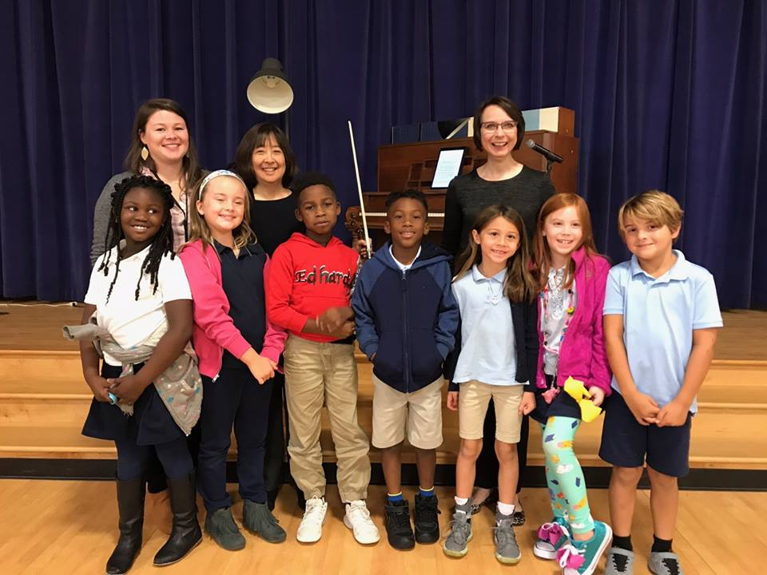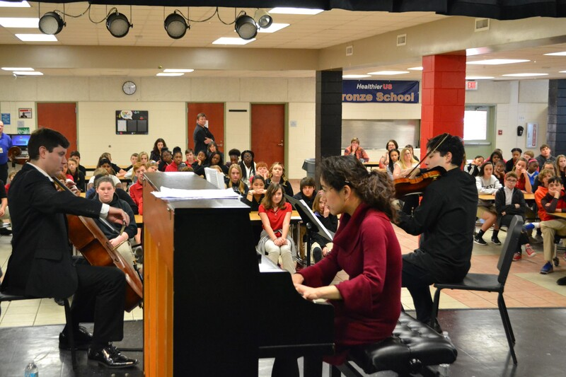

Hildy Aldrich Memorial Fund

In partnership with her beloved Friends of Music, the Aldrich Family has announced a “Hildy Fund” to help promote music education at St. Helena Elementary School. You can help by providing an additional contribution to this fund.

